Ouput 1:

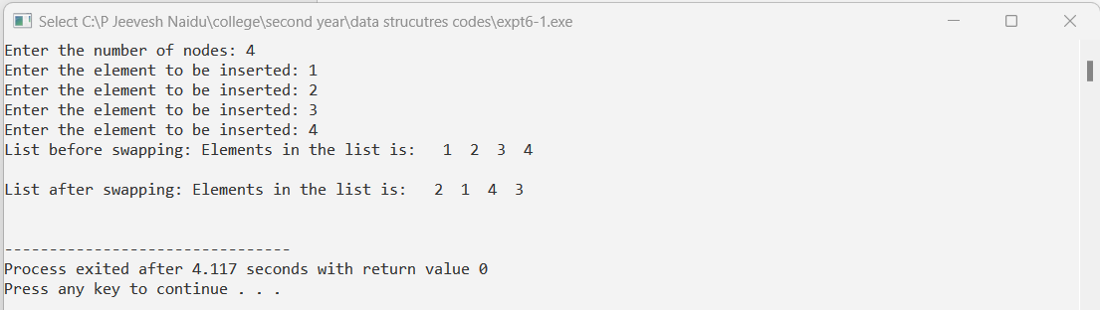

Output 2:

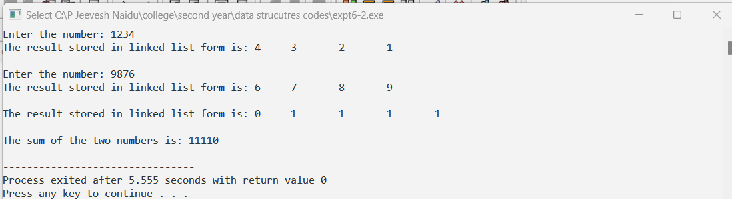

Ouput 3:

